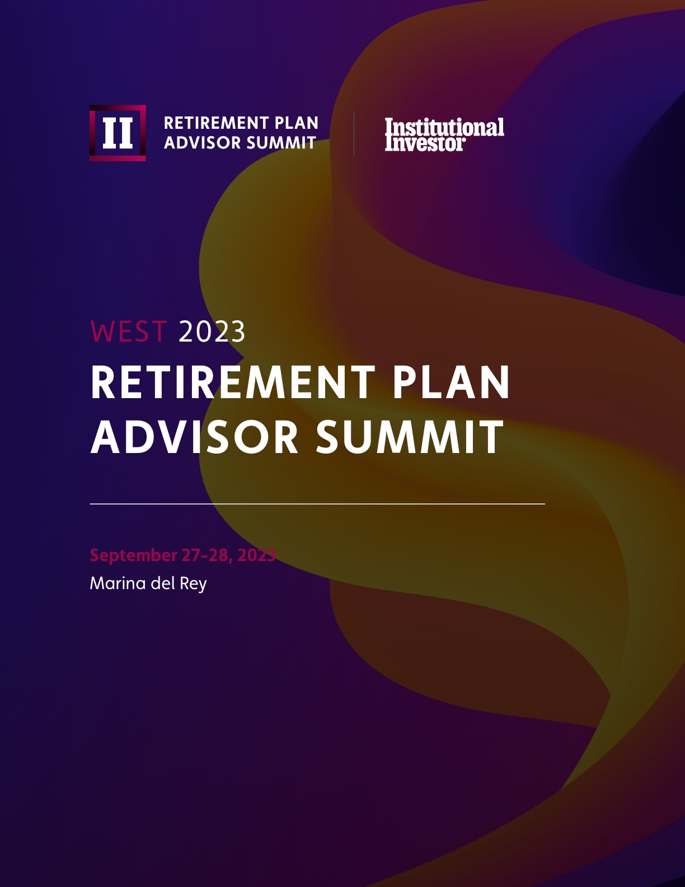

Co-Lead Sponsor
TransAmerica
Fisher Investments
Franklin Templeton
Nuveen

Associate Sponsor

Advisory Board
Institutional Investor Forums would like to thank our esteemed advisory board for their continuous support, guidance, and contribution to the summit’s content to make sure we address and deliver the most relevant and forward-thinking content for you and your peers.
- Kyle Nelson, Senior Retirement Plan Advisor, bergakdv
- Michael Sasso, Principal, CAPTRUST
- Constantine Mulligan, Partner, Midwest, Cerity Partners
- Chuck Williams, Managing Partner, Chief Executive Officer, Finspire
- Amy Glynn, Managing Partner, GRPAA
- Brad Arends, Co-Founder, Chief Executive Officer, intellicents
- Joshua Ulmer, Executive Director, Institutional Consulting Director, Graystone, Morgan Stanley
- Sean Kelly, Vice President, Heffernan Financial Services
- Janine Moore, Senior Vice President, Retirement Practice Leader, HUB Retirement and Wealth Management
- Rick Rodgers, Principal, Innovest Solutions
- Todd Kading, Chief Executive Officer, Co-Founder, Leafhouse Financial
- Stephen A. Oliver, Founder, Manhattan Ridge Advisors
- Saumen Chattopadhyay, Chief Investment Officer, OneDigital Retirement + Wealth
- Jamie Linkowski, President, PRIMESolutions Advisors, LLC
- Matthew Eickman, National Retirement Practice Leader, Qualified Plan Advisors (QPA)
- George Fraser, Managing Director, Retirement Benefits Group
- Kelli J. Davis, Vice President, Retirement Plan Consulting
- Barbara Delaney, Principal, StoneStreet | Renaissance (SSRBA)
- Erin Hall, Managing Director, Strategic Retirement Partners
- Jeff Cullen, President, Strategic Retirement Partners
- Stephen M. Welch, Vice President, Corporate Retirement Director, The Foote Welch Group Morgan Stanley Wealth Management
- Brett Shofner, President, Work Plan Retire
The Future of RPAs:
Innovations, Disruptions, and Opportunities for Advisors

Over one and half days, Institutional Investor’s Inaugural Retirement Plan Advisor Summit will provide senior-level executives the most innovative and essential retirement plan advisor firms the opportunity to share ideas and experiences on some of the most pressing issues their clients and their businesses are facing today. The sessions will be formatted as case studies, industry-expert presentations, discussion tables, and workshops to foster collaboration and idea-sharing amongst the leaders in the ever-evolving retirement plan advisor industry. Attendees will share ideas and discuss solutions to some of the most predominant issues facing the industry today, including:

Over the past 32 years, Institutional Investor has developed deep expertise within the defined contribution industry and built c-suite level relationships with the most significant plan sponsors nationwide. It has recently created elite memberships, conferences, and content for the flourishing independent registered investment advisor businesses. Building on the success of these endeavors, the next step was clear: create a unique, elite conference for retirement plan advisors. This critical group meets with the retirement planning and financial advisor populations.

We hope you will join us for our 2nd Retirement Plan Advisor Summit, September 27-28, 2023, in LA!

Tuesday, September 26, 2023
5:30-7:00 PM
Welcome Reception

Wednesday, September 27, 2023
8:15 am – 9:00 am (45)
Foyer
Registration, Continental Breakfast

9:00 am – 9:05 am (5)
Forum Ballroom
Introduction and App Tutorial
Everything you need can be found on our app, including program details, speaker biographies, benchmarking survey results, information on other attendees, white papers, and access to the speaker presentations we have been authorized to make available.
Presented by:
- Cynthia Huynh, Senior Director, Investor Relations | Program Manager, RPAS, Institutional Investor
- Kandeel Zulfiqar, Client Services Manager, Institutional Investor

9:05 am – 9:15 am (10)
Forum Ballroom
Chairperson’s Welcome
Summit Chairperson:
- Joshua Ulmer, Executive Director, Institutional Consulting Director, Graystone, Morgan Stanley

9:15 am – 10:00 am (45)
CIO/ Head of Investments Panel Discussion
Mastering the Art of Selecting Game-changing Trends and Services to Catapult Your Business to the Top!
In today's fast-paced and dynamic business environment, it's crucial for businesses to stay up-to-date with the latest market trends and make smart investment decisions to stay ahead of the competition. We’ll discuss key factors to consider when selecting the right service and investment lineup for your business and how to leverage these to elevate your business to the next level.
- How to stay up-to-date with the latest market trends and identify the best opportunities for investment.
- The importance of a diversified investment portfolio and how to select the right mix of investments to achieve your business goals.
- The impact of changing regulations and compliance requirements on investment and service choices.

Moderator:
- TBD
Panelists:
- TBD

10:00 am - 10:15 am (15)
Forum Ballroom
Polling Session
What are the investment issues, concerns, and priorities of your peers? Attendees will be polled on several high-interest topics using an anonymous, interactive electronic response system in this opening session and subsequent sessions. The aggregated results of these polls will be displayed instantaneously on-screen to help illuminate the discussions which follow. By doing this, we will provide all attendees with valuable benchmarks and unique insights into the concerns of retirement plan advisors and their clients.
Moderated by:
- Joshua Ulmer, Executive Director, Institutional Consulting Director, Graystone, Morgan Stanley

10:15 am – 11:00 am (45)
Forum Ballroom
Panel Discussion
Reshaping Retirement Plans Through Workplace Financial Wellness Integration
The retirement industry continues to evolve, and there is an inherent connection between saving for retirement, managing pension benefits, handling personal finances, staying healthy, and doing it all within the workplace. This panel of peers and industry experts addresses the evolution of the retirement plan advisor’s value proposition from its focus on 401(k) and investments to a more holistic “workplace financial wellness,” integrating defined benefit plans along with workplace wellness solutions to help employees evaluate their unique situation so they can achieve their current and long-term goals.

Moderator:
- Ryan Franken, National Sales Manager, Institutional Markets, Transamerica
Panelists:
- Bob McBride, Vice President of Workplace Solutions, Transamerica
- TBD

11:00 am – 11:30 am (30)
Foyer
Coffee Break

11:30 am – 12:15 pm (45)
Forum Ballroom
Panel Discussion
Making Managed Accounts the QDIA – A Framework for Due Diligence, Implementation, and Client Service
Moderator:
- TBD
Panelists:
- Chris Braccia, Chief Investment Officer, Manhattan Ridge Advisors
- Fisher Investments

12:15 pm – 1:45 pm
La Vista Terrace
Lunch

1:45 pm – 2:15 pm (30)
Forum Ballroom
Fireside Chat
Income is the New Outcome
Moderator:
- TBD
Panelists:
- Nuveen

2:15 pm – 3:00 pm (45)
Panel Discussion
One Trick Ahead of Disaster: Best Practices Reflecting Lessons from Litigation
In an era of widespread retirement fee litigation, plan sponsors need to be prepared for expected challenges to their decisions and processes. We are bringing in experts to address trends in plaintiffs' complaints and Federal courts' rulings and to provide practical strategies for adding value to the advisory services you provide your clients. Our expert panel will:
- Discuss Federal courts' ongoing application of the US Supreme Court's Northwestern and Tibble opinions
- Distinguish among claims relating to investment performance, investment cost, and a mix of both
- Share strategies for educating clients and implementing best practices that anticipate future challenges
Forum Ballroom
Presented: TBD

3:00 pm – 3:30 pm (30)
Foyer
Coffee Break

3:30 pm – 4:15 pm (45)
Forum Ballroom
Panel Discussion
TBD

Moderator:
Panelists:

4:30 pm – 5:15 pm (45)
Forum Ballroom
Panel Discussion
Implementing DEI & ESG Strategies in Your Retirement Practice: Moving from Theory to Action
As firms reopen and adjust to new norms, the c-suite is critical in helping their employers navigate the post-pandemic workplace and putting DEI and ESG into action by prioritizing diverse leadership and staff.

Moderator:
- Stephen M. Welch, Vice President, Corporate Retirement Director, Financial Advisor, The Foote Welch Group Morgan Stanley Wealth Management (proposed)
Panelists:
- Steve Oliver, Founder, Manhattan Ridge Advisors (proposed)
- Tiffany McGhee, Chief Executive Officer, Chief Investment Officer, Pivotal Advisors (proposed)
- James Strother, Retirement Plan Advisor, HUB International

5:15 PM
Cocktails & Dinner
TBD

6:15 PM
Evening Free for Private Functions

Thursday September 28, 2023
8:30 am – 9:30 am (60)
Foyer
Morning Discussion Tables
At peer-moderated tables of 8-10 participants, delegates will share their opinions and compare notes on several vital issues identified by Advisory Board members as worthy of discussion. Delegates will be asked to contribute to the overall discussion to share information and learn from others’ experiences.

Discussion Table 1 – The Post-Pandemic Workplace: Key Considerations for Employers
Moderated by: TBD

Discussion Table 2 – Foundation of an Efficient Run Investment Committee
Moderated by: TBD

Discussion Table 3 – Best Practices: The Impact of PEPs and MEPs on Retirement Planning
Moderated by: TBD

9:30 am – 10:15 am (45)
Forum Ballroom
Panel Discussion
Clearing Up Confusion: Effective Communication of the SECURE Act in Retirement Planning
This panel will bring together experts to discuss the implications of the SECURE Act. We will discuss how these changes impact retirement provisions and what steps can be taken to communicate these changes to plan participants effectively. They will also address common misconceptions about the SECURE Act and provide strategies for overcoming confusion and promoting understanding.
Moderator:
Panelists:
- Thane Walton, United Planners

10:15 am – 10:30 am (15)
Foyer
Coffee Break

10:30 am -11:15 am (45)
Forum Ballroom
Panel Discussion
Synergies in Retirement and Wealth Management: Creating a Win-Win Situation
As the connection between benefits and wealth grows, we will examine the benefits and challenges of integrating wealth management into a retirement plan advisory practice and discuss best practices for success. Plan advisors have long understood that integrating wealth management can catapult revenue, improve client retention and satisfaction, enhance their competitive advantage, and increase their expertise in the industry.

Moderator:
- TBD
Panelists:
- Kevin Price, Advisor, Insight Financial Solutions

11:15-12:00 am (30)
Forum Ballroom
Plan Sponsor Panel
Unlocking Success: Mastering Client Acquisition and Excelling in RFPs
- What are the answers and tips to winning an advisor’s RFP?
- What are the right questions to ask?
Moderator:
- Veronica M. Bray, Chief Executive Officer, Retirement Plan Advisor Search
Panelists:
- Wynette Southerland, Benefits Manager, The Fresh Market
- Paul Constantino, Director of Accounting, Children’s Home Society of North Carolina
- Kelley Salmon, HR Recruitment and Retention Manager, AuthoraCare Collective

12:00 pm – 1:30 pm
Foyer
Lunch
1:30 pm
West Retirement Plan Advisor Summit Concludes!

